Real Ethics

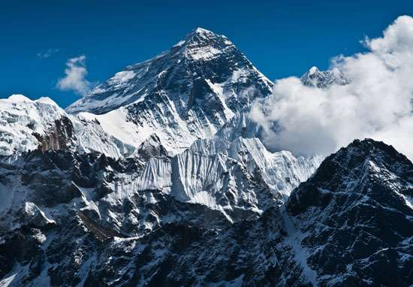
Some 40 climbers are winding their way to the top of Mt. Everest. About 300 meters below the summit sits a British mountain climber in trouble, collapsed in a shallow snow cave. Most of those on the way up just look while continuing their climbs. Sherpas from one passing team pause to give him oxygen before moving on. Within hours, David Sharp, 34 is dead of oxygen deficiency on the mountain.

A climber who passed by says: “At 28,000 feet it’s hard to stay alive yourself…he was in very poor condition … it was a very hard decision … he wasn’t a member of our team.”

Someone who made the summit in the past says, “If you’re going to go to Everest…I think you have to accept responsibility that you may end up doing something that’s not ethically nice…you have to realize that you’re in a different world.”

After hearing about this case, Sir Edmund Hillary, who was one of the first two climbers to reach the top in 1953 said, “Human life is far more important than just getting to the top of a mountain.”

Questions:

1. Who’s right and who’s wrong here?
2. In our personal affairs, daily lives, and careers, we are all, in our own ways, climbing Mt. Everest. What are the ethics of our climbs? How often do we notice others in trouble, struggling along the way? And, like the mountain climbers heading to the summit of Everest, how often do we pass them by to continue our own journeys?
3. Can you identify examples – from business, school, career, sports and so on – that pose similar ethical dilemmas?

